**What is JAVA**: - Java is programming language and computing platform. Java applications combine the Java Runtime and application together. Platform Independent.

**Java Environment: -**

JRE, JDK, JVM - **Platform Dependent**.

**JDK** - Intended for software *developers*. Consist tools such as compiler, Javadoc, a debugger.

**JRE** – Contains Java Library, for *end users.*

**JVM** – Abstract Machine, Execute Bytecode.

What is SCM Version Control – Source Control Management.

Way to manage and document changes for developers. Also known as VCS – Version Control Management. D(Distributed)VCS AND C(Centralized)VCS

**Stack and Heap -** JVM divides the memory.

Head – stores actual objects.

Stack – generates when a thread creates. Memory is allocated per thread.

**Input Stream class** – superclass of all io classes. Represent input stream of bytes.

First, JVM executes the static block, then it executes static methods, and then it creates the object needed by the program

**output stream** - writing data/streams of raw bytes to file or storing data to file

error stream

**wrapper classes -**

String class - Immutable which means a constant and cannot be changed once created

string pool - Storage area in *Java heap* where string literals stores.

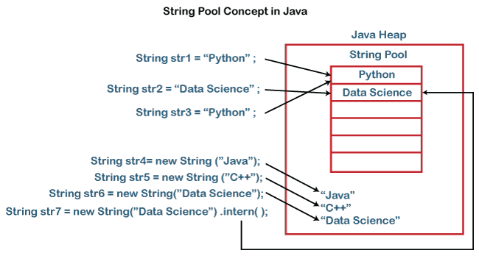

Garbage collection

string - mutable /nonmutable (string buffer and builder)

equals and hashcode

Super and new in java

constructor

final, finally, finalize difference –

Final – Access Modifier

Finally – Block in exception handling

Finalize – method of object class